Specialized Hardware:

Arithmetic Pipelining

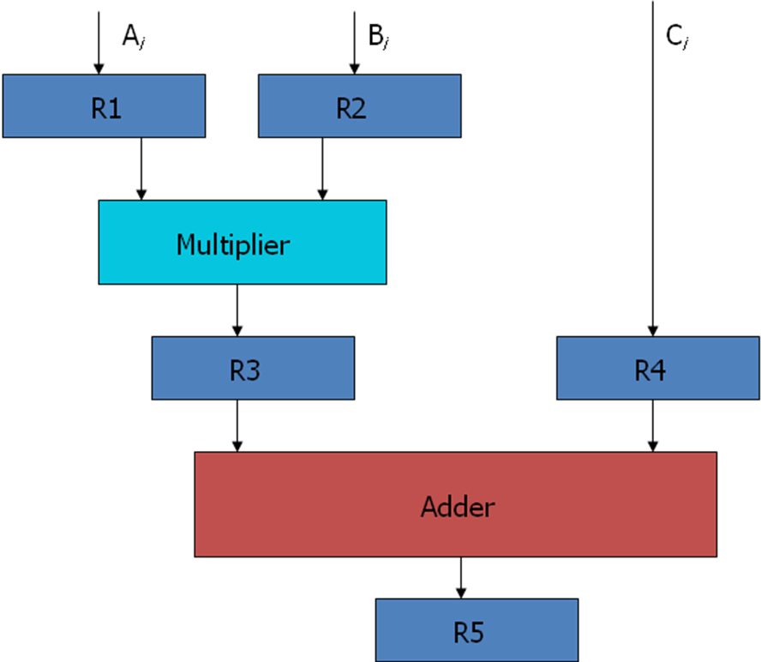
Fig 4-1: Example of pipeline processing

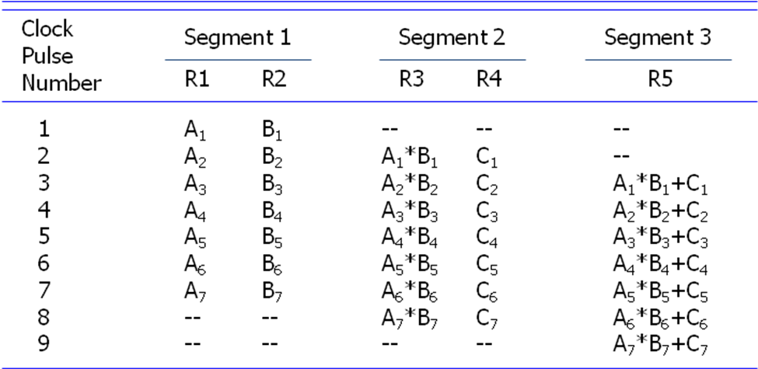

Table 4-1: Content of Registers in Pipeline Example

General Considerations (Speed up of a pipeline system)
Any operation that can be decomposed into a sequence of suboperations of about the same complexity can be implemented by a pipeline processor.
The general structure of a four-segment pipeline is illustrated in Fig. 4-2.
We define a task as the total operation performed going through all the segments in the pipeline.
The behaviour of a pipeline can be illustrated with a space-time diagram.
It shows the segment utilization as a function of time.
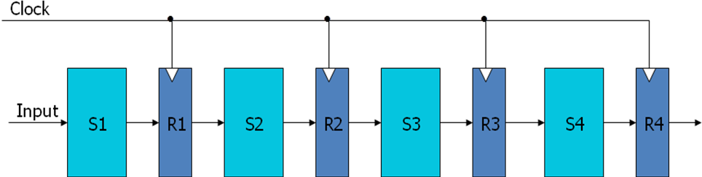
Fig 4-2: Four Segment Pipeline

The space-time diagram of a four-segment pipeline is demonstrated in Fig. 4-3.
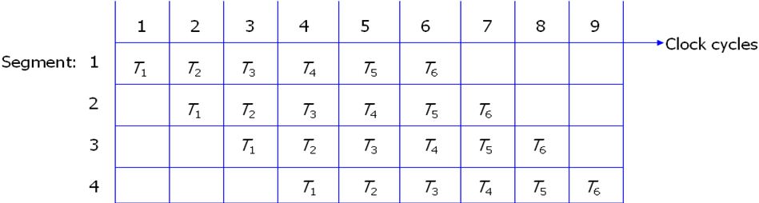
Fig 4-3: Space-time diagram for pipeline
Where a k-segment pipeline with a clock cycle time tp is used to execute n tasks.
Where, clock cycle time t_{p} is the time required to process a task in each segment.
For Pipeline
The first task T1 requires a time equal to kt_{p} to complete its operation.
The remaining n-1 tasks will be completed after a time equal to (n-1) t_{p}.
Therefore, to complete n tasks using a k-segment pipeline requires k+(n-1) clock cycles.
For Non-pipeline
Consider a non-pipelined unit that performs the same operation and takes a time equal to t_{n} to complete each task.
The total time required for n tasks is nt_{n}.

Speed up of a pipelining processing
The speedup of a pipeline processing over an equivalent non-pipeline processing is defined by the ratio S = nt_{n}/(k+n-1)tp .
If n becomes much larger than k-1, the speedup becomes, S = tn/tp.
If we assume that the time it takes to process a task is the same in the pipeline and non-pipeline circuits, i.e., t_{n} = kt_{p}, the speedup reduces to S=ktp/tp=k.
This shows that the theoretical maximum speed up that a pipeline can provide is k, where k is the number of segments in the pipeline. S_{max} = k.
To duplicate the theoretical speed advantage of a pipeline process by means of multiple functional units, it is necessary to construct k identical units that will be operating in parallel.

Arithmetic Pipeline
Pipeline arithmetic units are usually found in very high speed computers o Floating–point operations, multiplication of fixed-point numbers, and similar computations in scientific problem
Floating–point operations are easily decomposed into sub operations.
An example of a pipeline unit for floating-point addition and subtraction is showed in the following: o The inputs to the floating-point adder pipeline are two normalized floating-point binary number
$$X=A×2^{a}$$

$$Y=B×2^{b}$$

A and B are two fractions that represent the mantissas
a and b are the exponents
The floating-point addition and subtraction can be performed in four segments, as shown in Fig. 4-6.
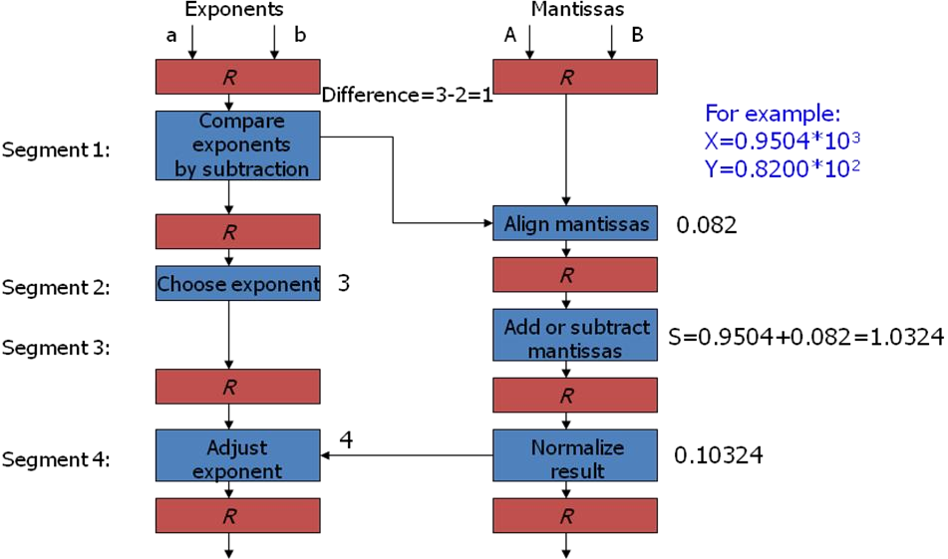
Fig 4-6: Pipeline for floating point addition and subtraction

The suboperations that are performed in the four segments are:
Compare the exponents
The larger exponent is chosen as the exponent of the result.
Align the mantissas
The exponent difference determines how many times the mantissa associated with the smaller exponent must be shifted to the right.
Add or subtract the mantissas
Normalize the result.
When an overflow occurs, the mantissa of the sum or difference is shifted right and the exponent incremented by one.
If an underflow occurs, the number of leading zeros in the mantissa determines the number of left shifts in the mantissa and the number that must be subtracted from the exponent.
The following numerical example may clarify the suboperations performed in each segment.
The comparator, shift, adder, subtractor, incrementor, and decrementor in the floating-point pipeline are implemented with combinational circuits.

